**CS:595 ENTERPRISE WEB APPLICATION**

**PROJECT**

**PIZZAPARTY.COM**



Team :

Arora Nikhil(narora2@hawk.iit.edu)

Namdeo Jyoti (jnamdeo@hawk.iit.edu)

Bhatia Varun (vbhatia2@hawk.iit.edu)

Poonia Urvashi (upoonia@hawk.iit.edu)

Shekhar Arvind (anln43@hawk.iit.edu)

**Introduction**

Technology Used:

|  |  |
| --- | --- |
| java | tomcat |
| xml | bootstrap |
| java script | ajax |

**About the project**

A website to deliver freshly-made and delicious pizzas in 30 minutes.

We offer customized and regular pizzas with plenty of side-dishes.

Our shop provides special offers and discounts to the registered

users.

Website features:

1. Special Offers and Discounts to the registered users.
2. Customization of Pizza available.
3. Dynamic Order Status presented.
4. Online Home-delivery and Online Pick-up option.

**Requirements:**

Java 1.8

Tomcat 7.0.34

MongoDb 3.04 -> This should be hosted in port 27017.

**References:**

|  |  |
| --- | --- |
| **Technologies Reference** | **websites** |
| Html References | <http://www.w3schools.com/html/> |
| JSP references | <http://www.tutorialspoint.com/jsp/> |
| Servelets | <http://www.tutorialspoint.com/servlets/> |
| javascripts | <https://developer.mozilla.org/en-US/docs/Web/JavaScript> |

[**Snapshots:**](https://developer.mozilla.org/en-US/docs/Web/JavaScript)

[**Homepage**- Here we can order items as a customer, admin or we can be guest.](https://developer.mozilla.org/en-US/docs/Web/JavaScript)

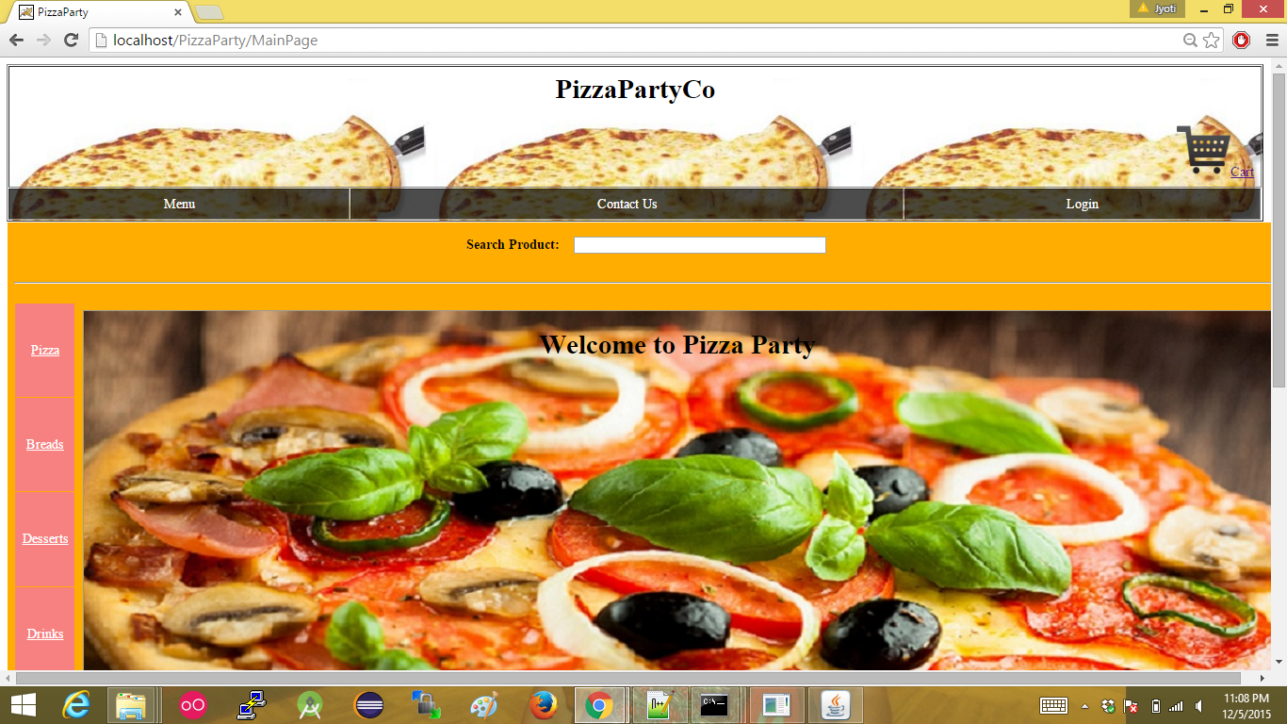

**Login Page-**

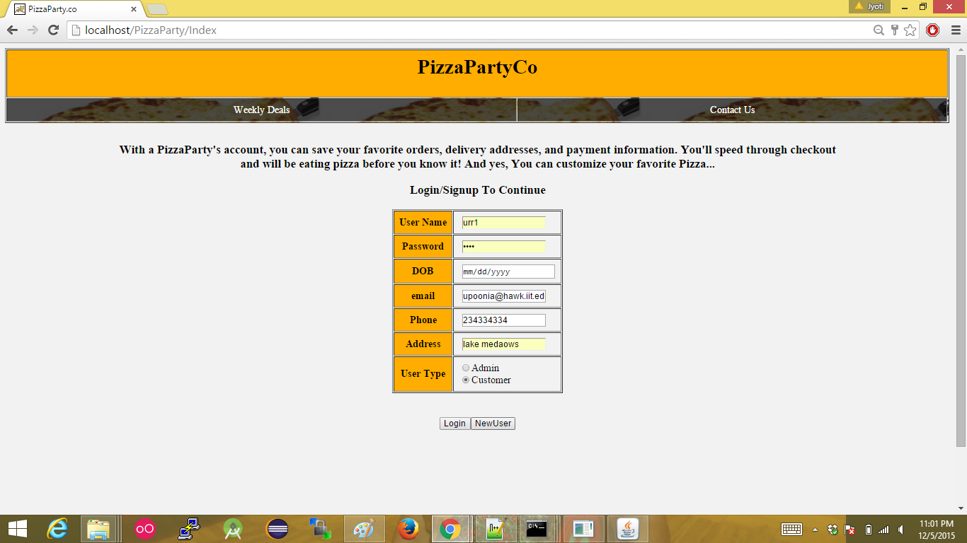

[**Dynamic search functionality using Ajax**](https://developer.mozilla.org/en-US/docs/Web/JavaScript) 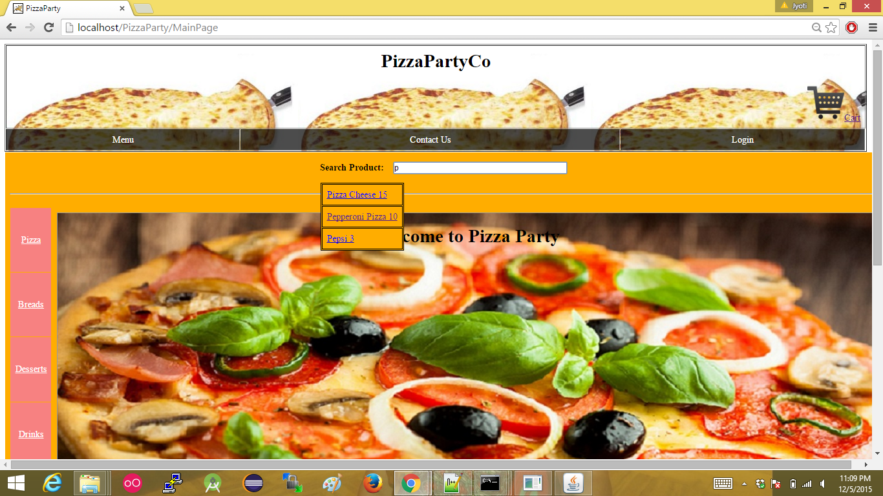

[**Displaying all the variety of pizza**](https://developer.mozilla.org/en-US/docs/Web/JavaScript)

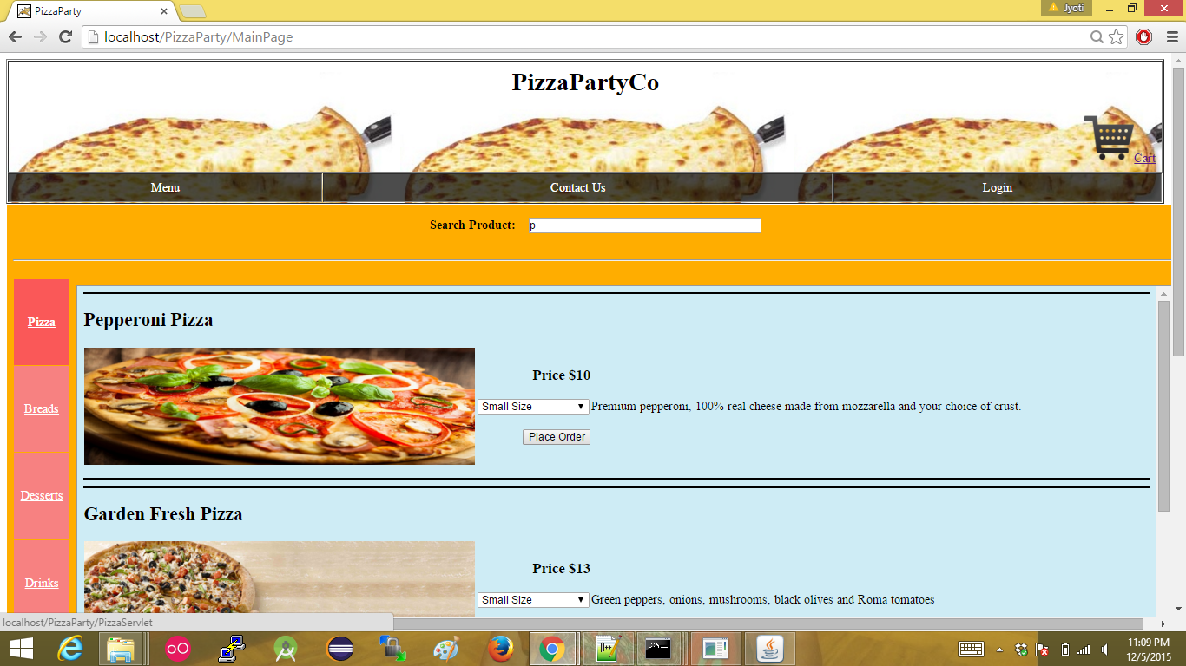

**Displaying all the breads to buy**

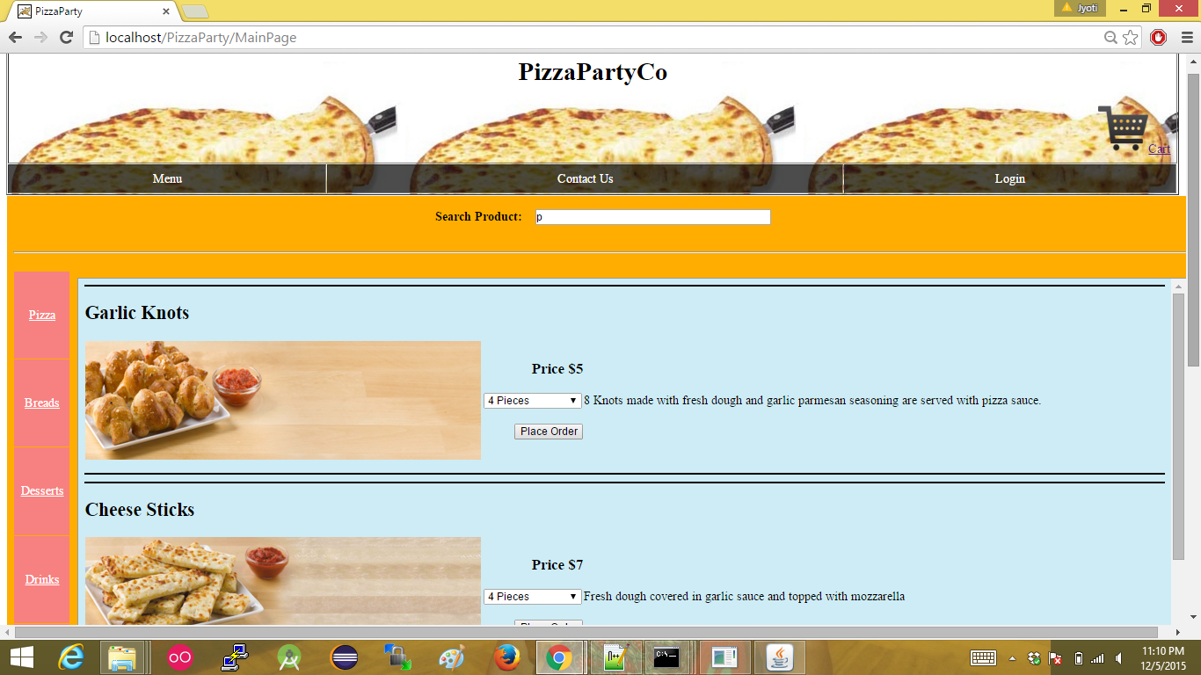

**Displaying all the Desert to select from to buy**

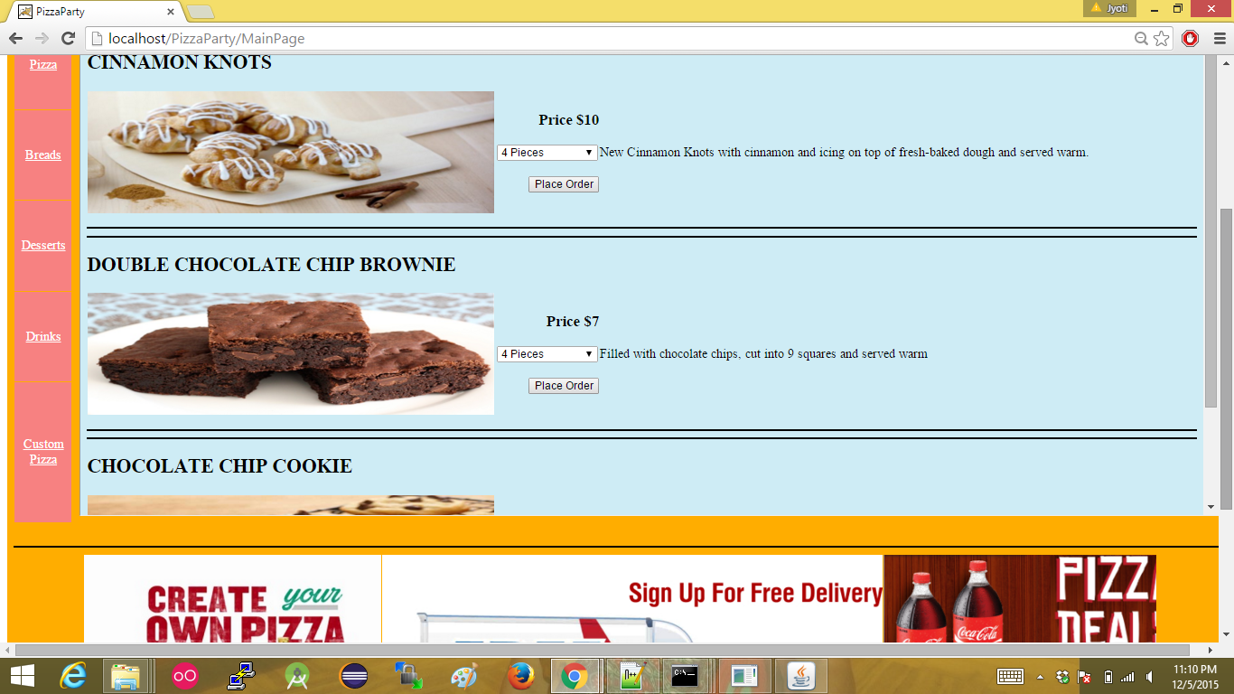

**Displaying all the drink available to drink**

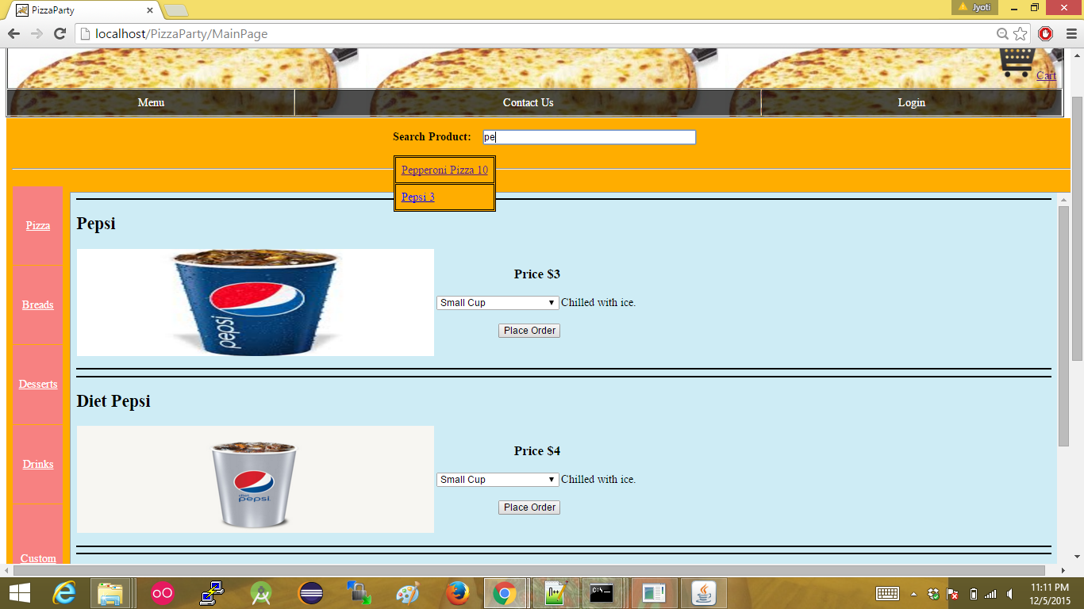

**Displaying all the custom options to create custom pizza**

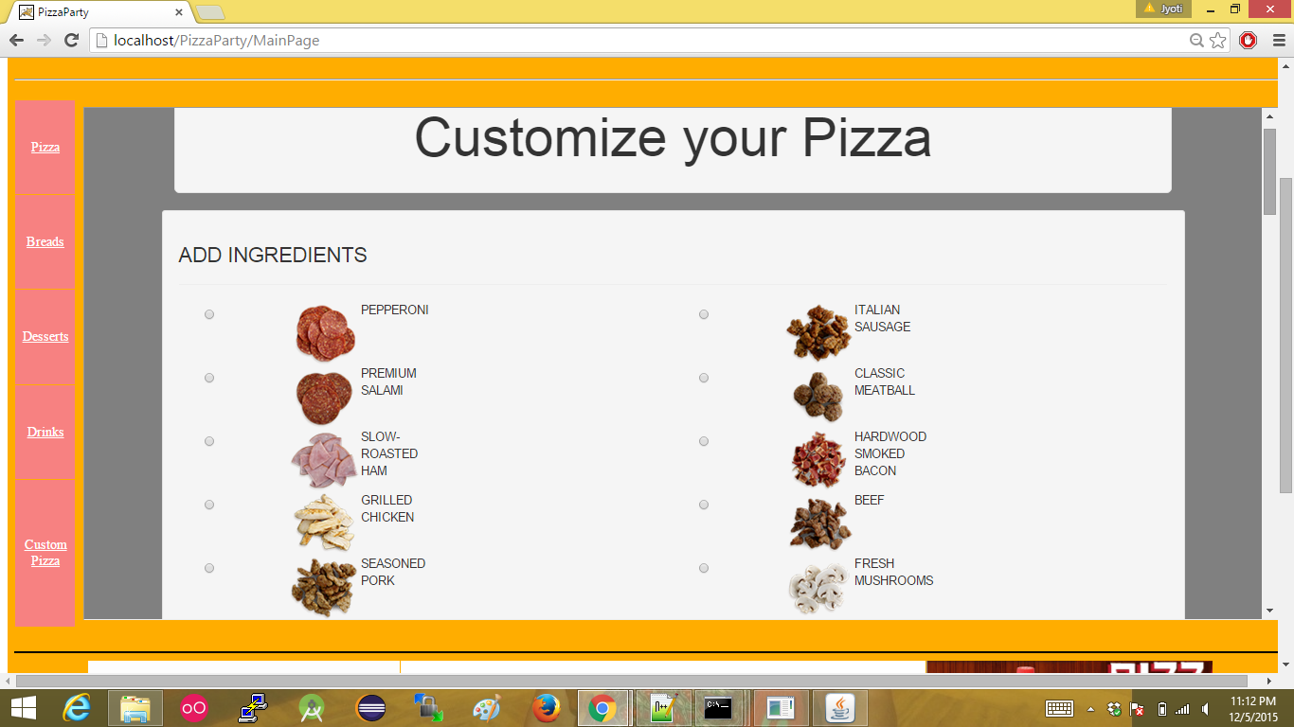

**Custom pizza sauce options**

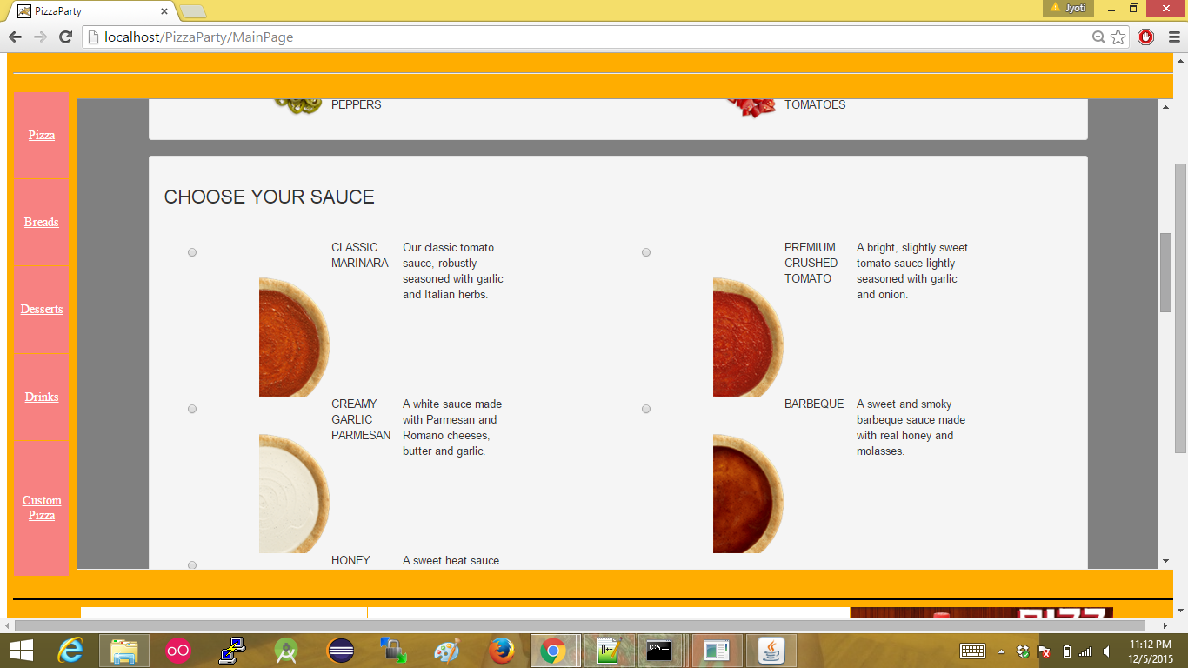

**Custom pizza cheese and size option**

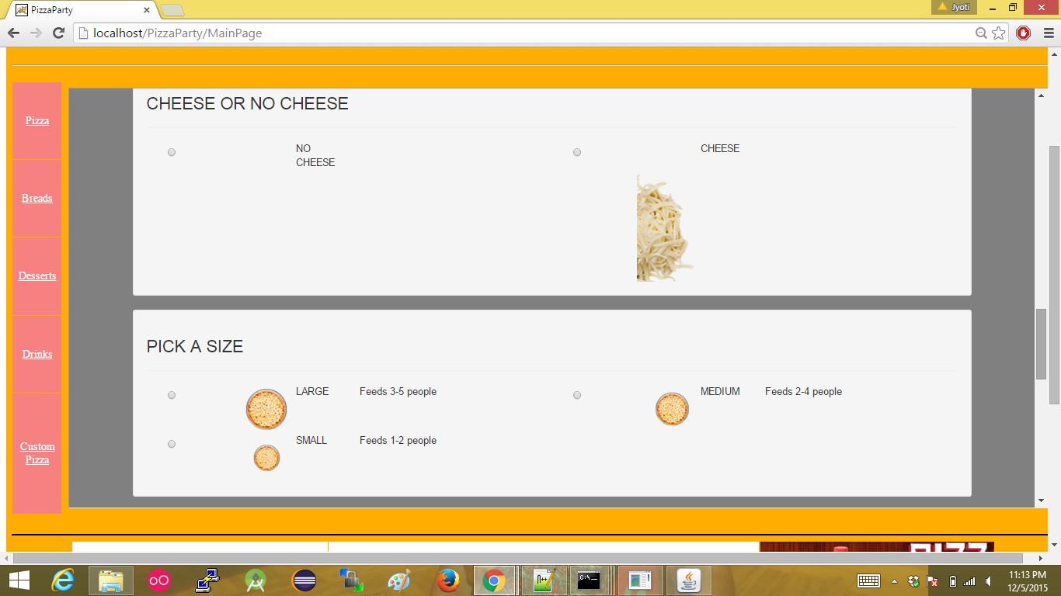

**Custom pizza a for choosing crust**

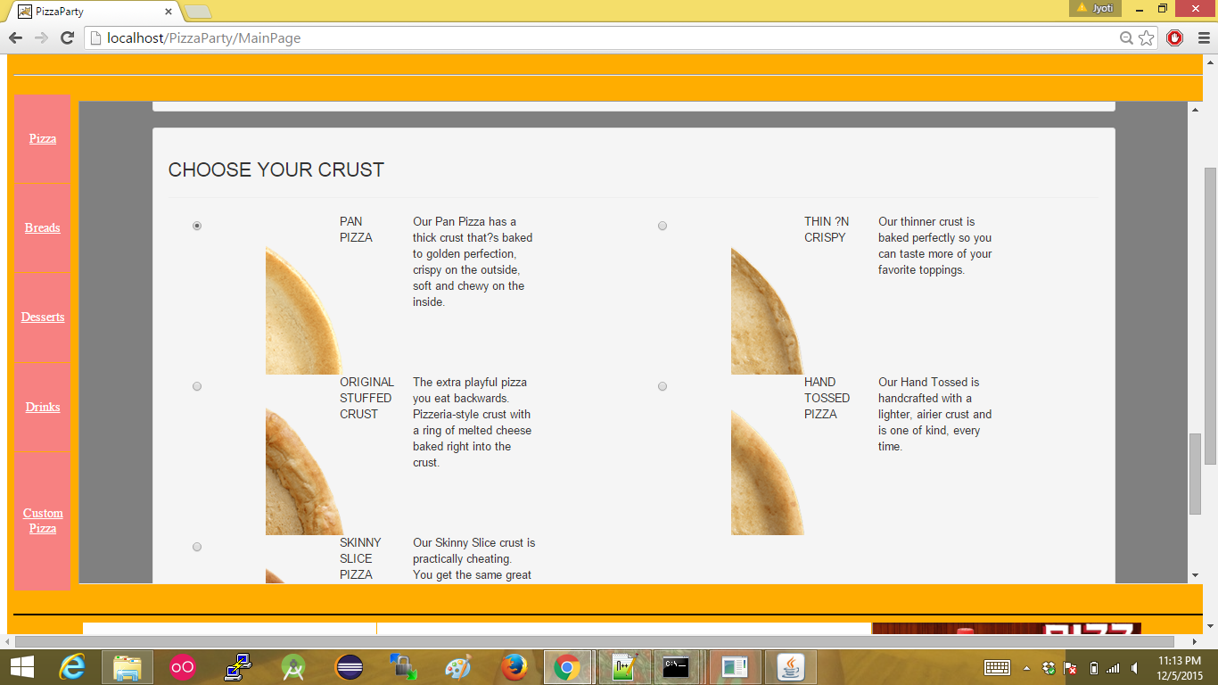

**Custom pizza final confirmation to display the final customization**

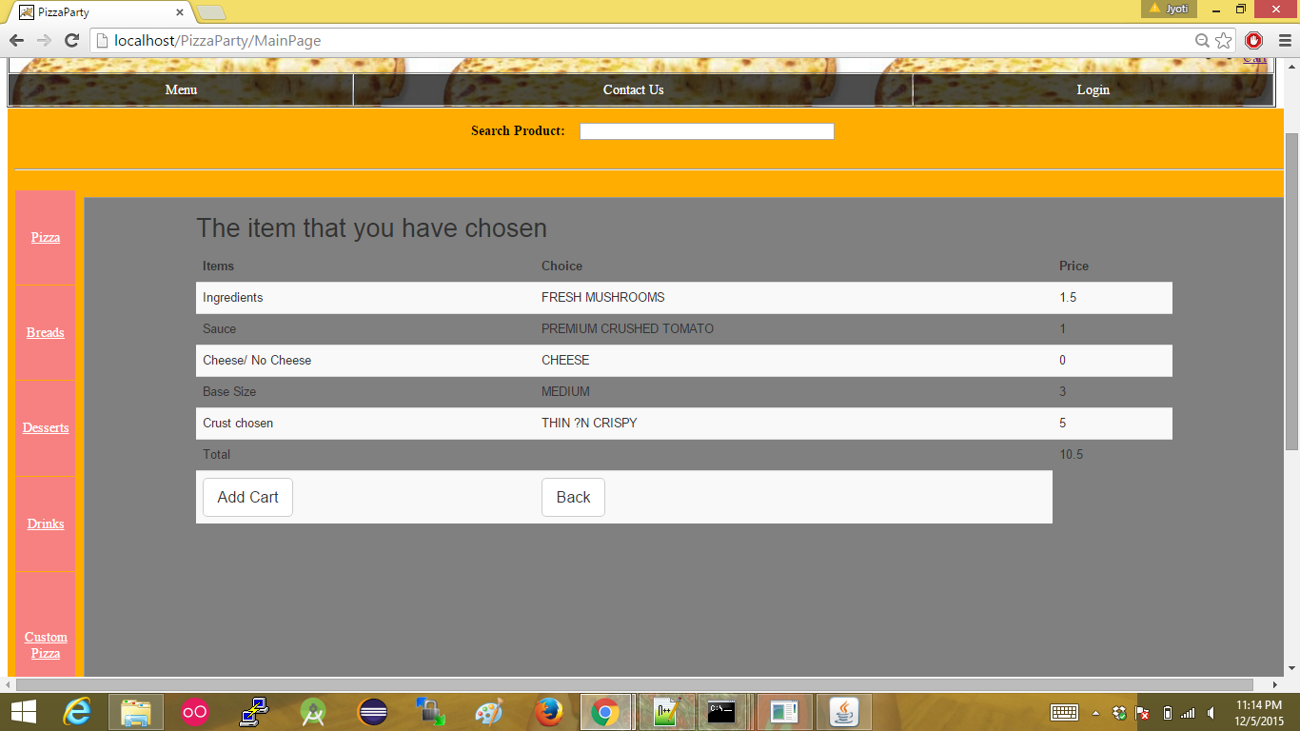

**Cart Functionality displaying all the items selected. User can update and delete the selection.**

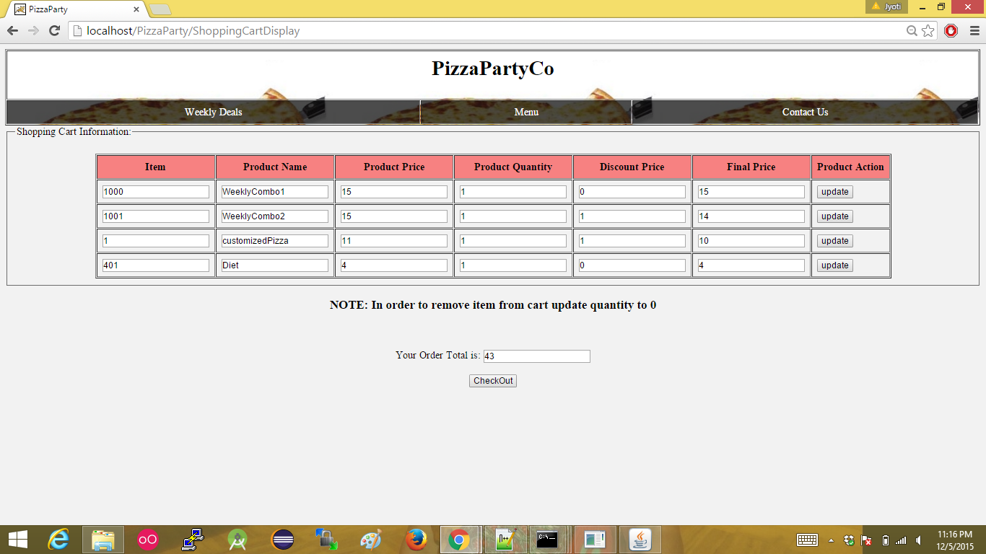

**The menu to display all the items in the site.**

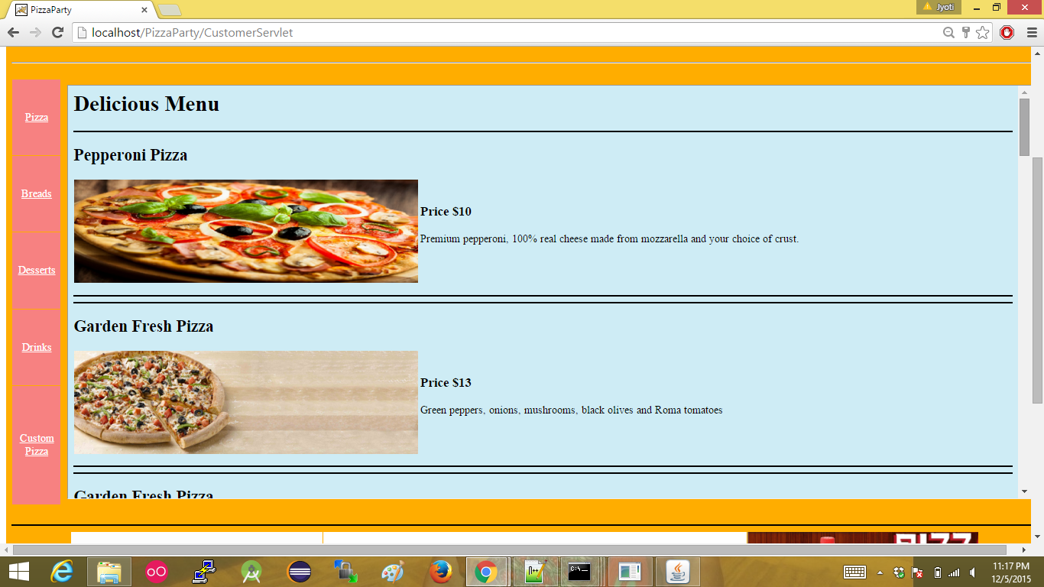

**Offers based on guest user and customer that have been registered**

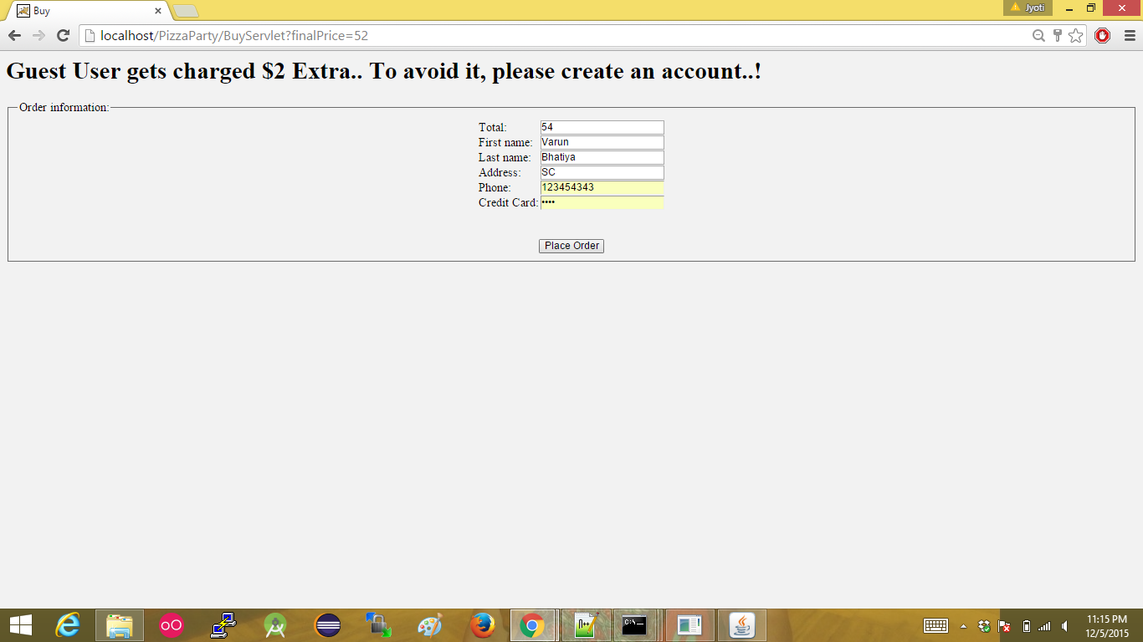

**Final confirmation**

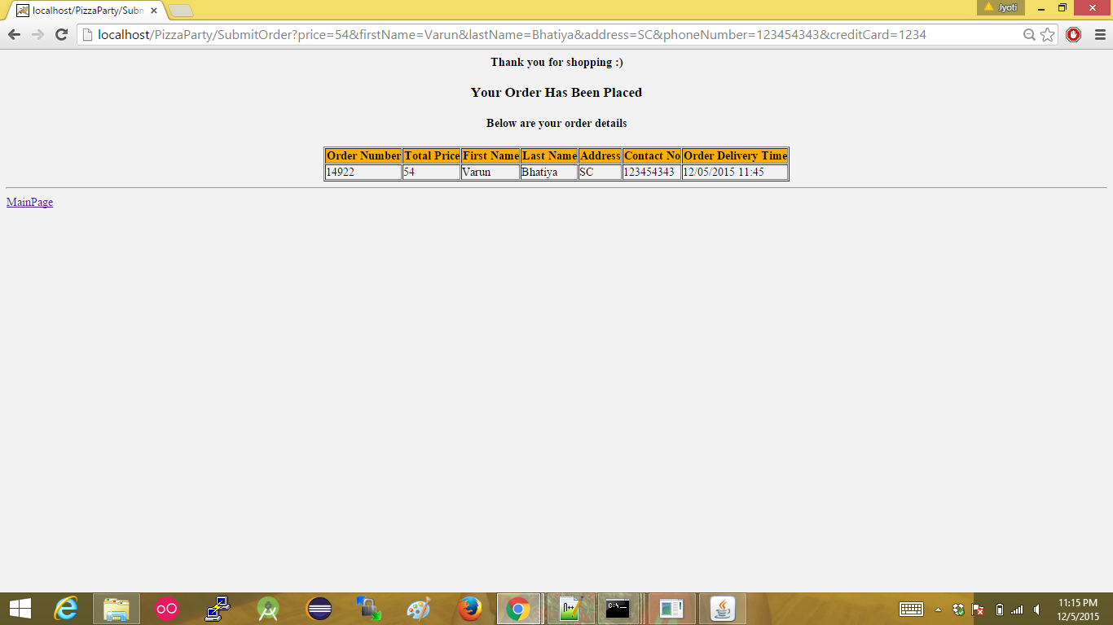

**Special offers for the week**

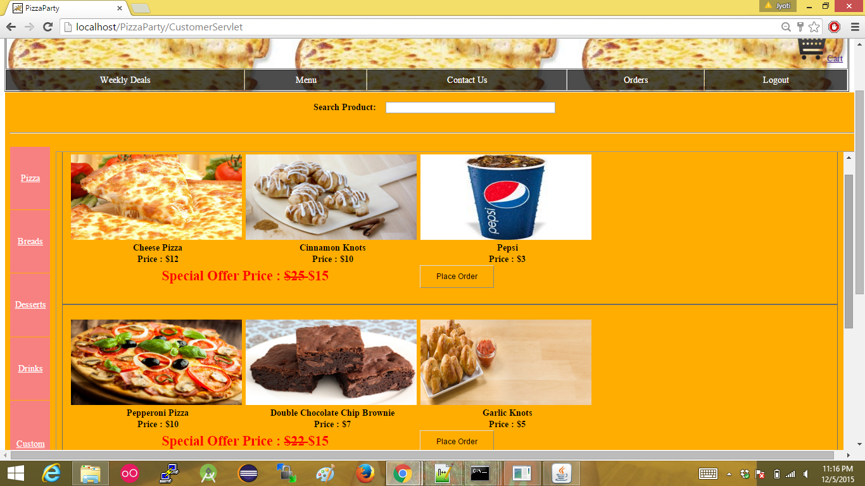

**Orders that have been selected**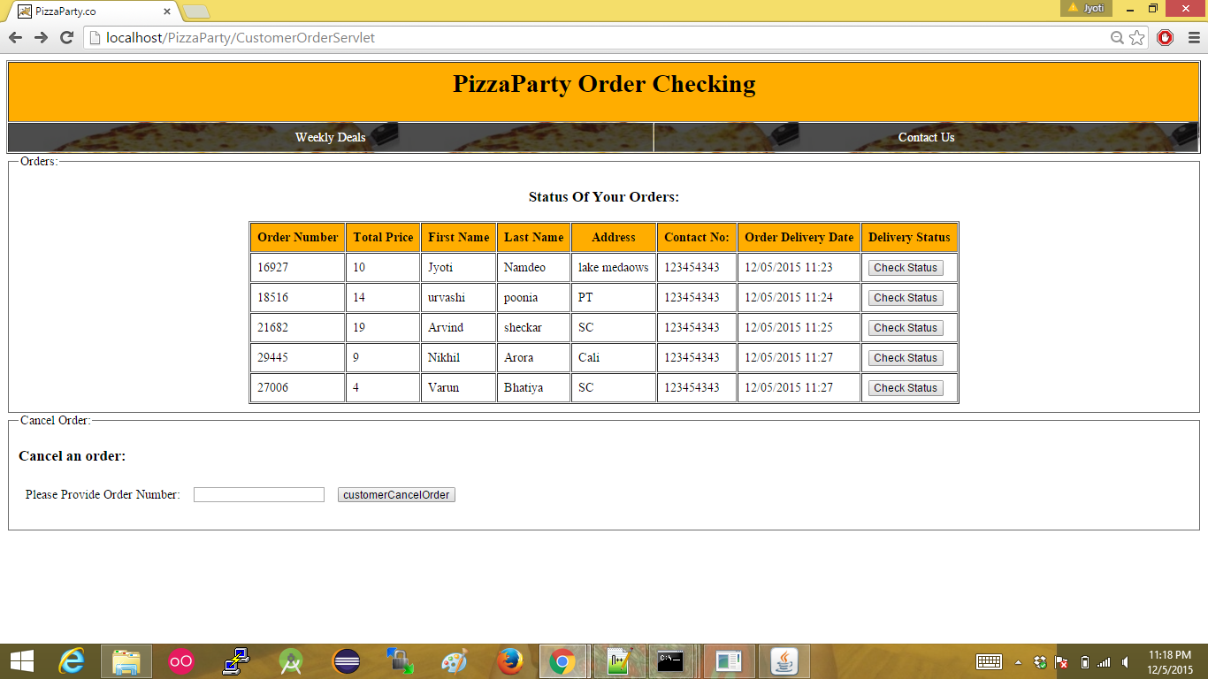

**Progress of the order**

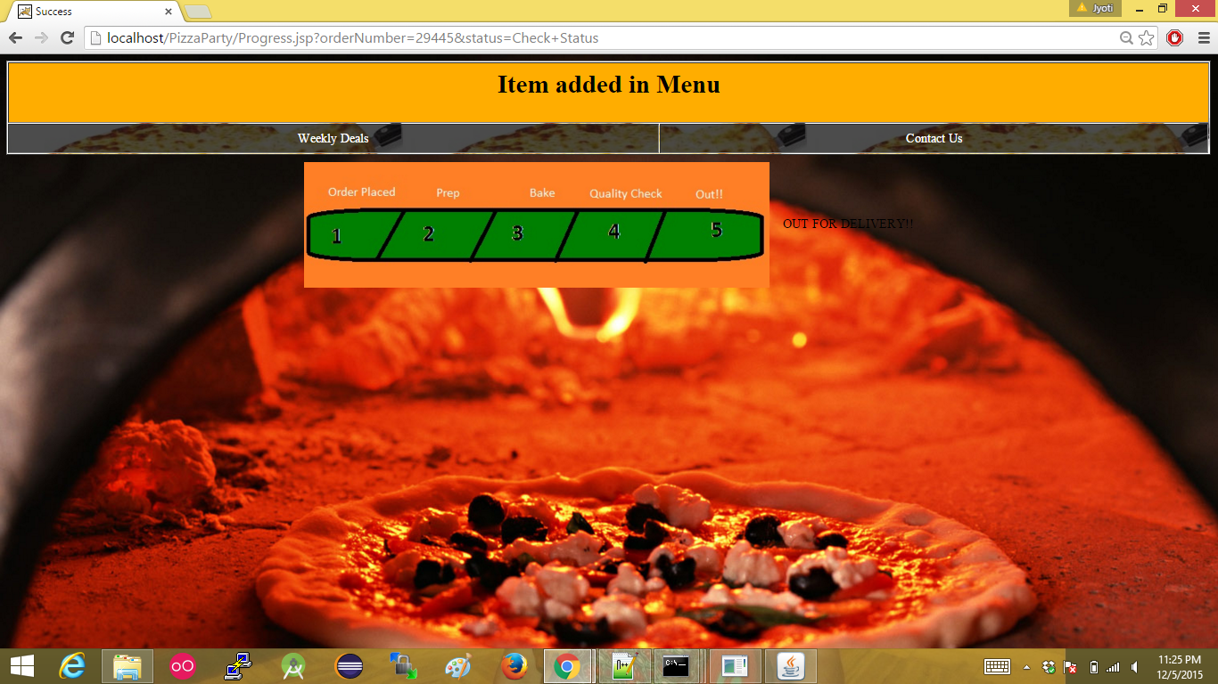

**Contact details page**

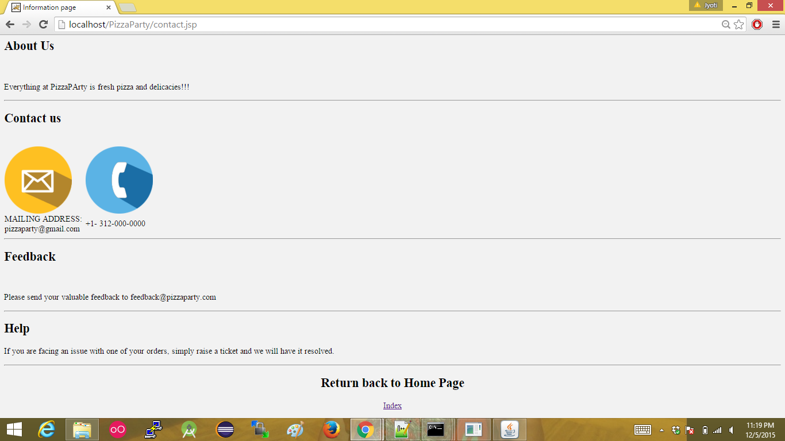

[**Admin Rights:** Admin can add, update and delete items in the shop.](https://developer.mozilla.org/en-US/docs/Web/JavaScript)

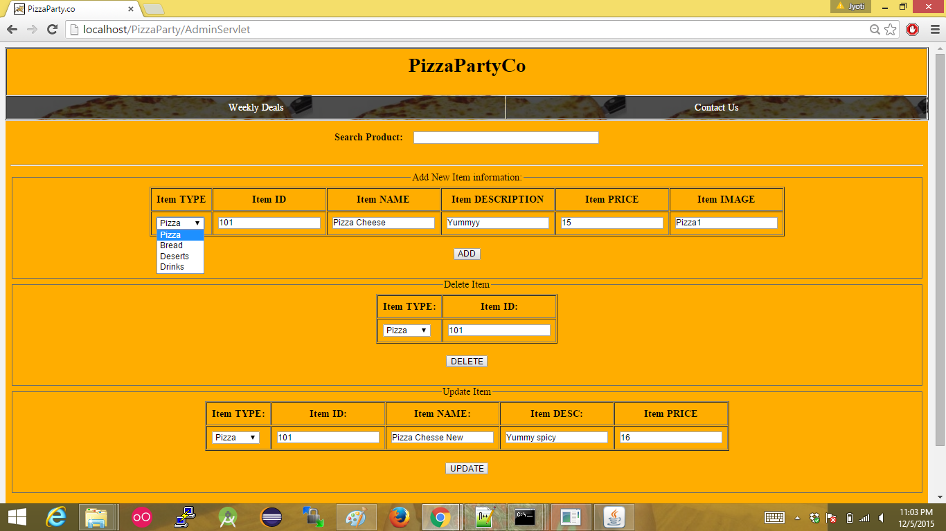

**Adding Items to the shop**

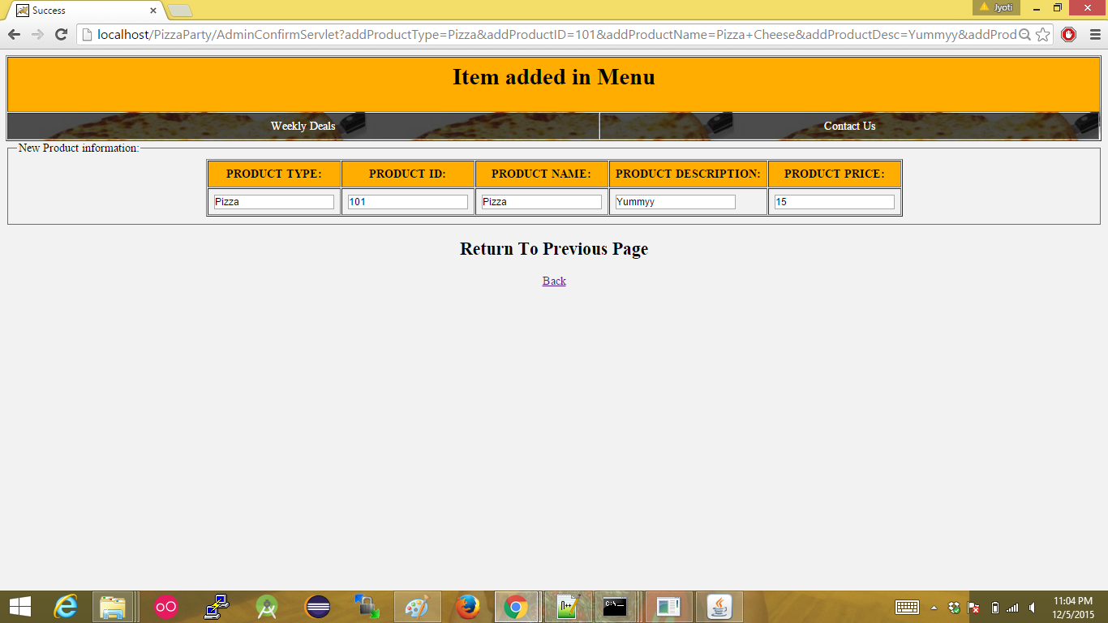

**Deleting items from the store**

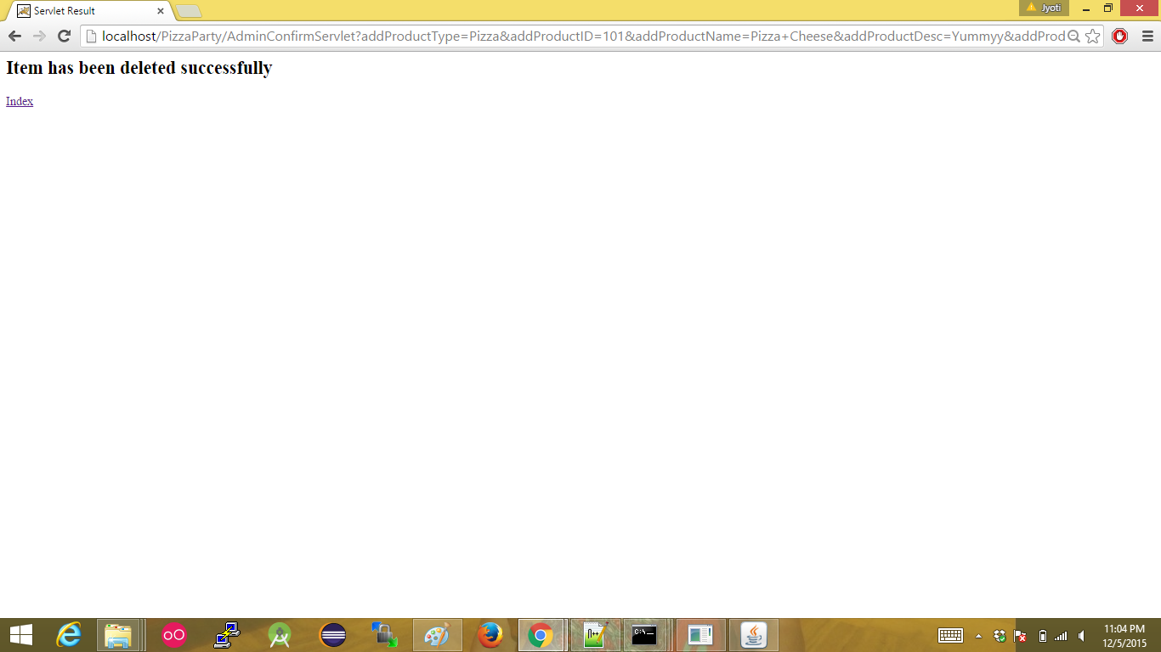

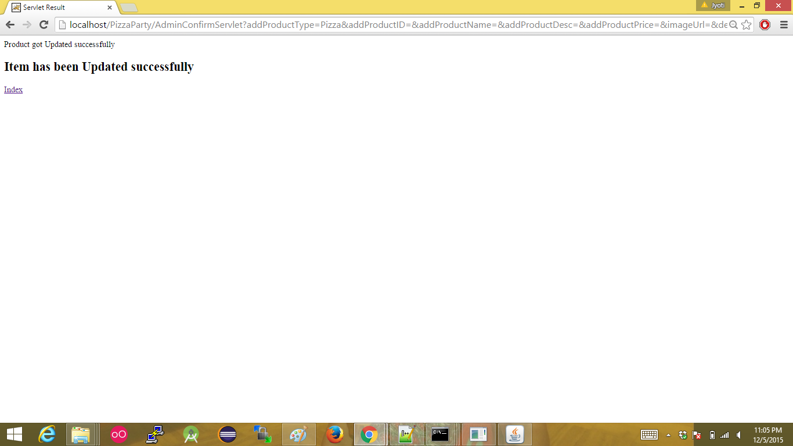

**Class Diagram:**